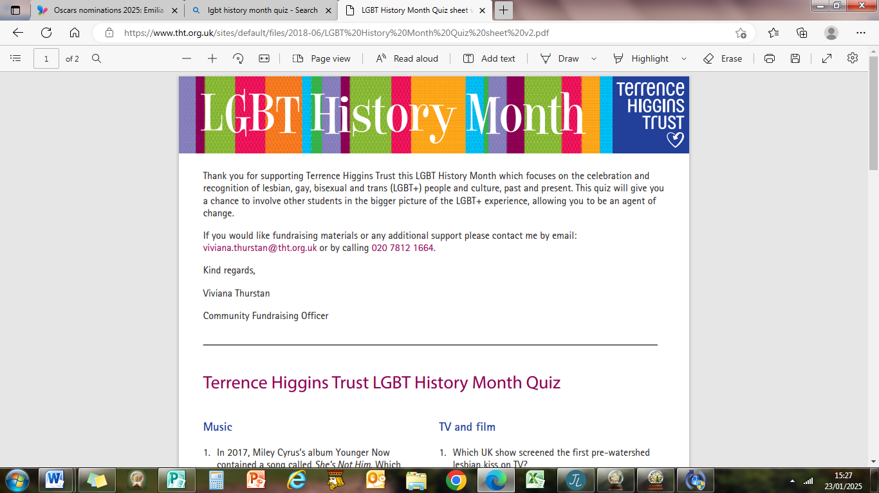
Quiz

Round 1 Music

- What singer fronted the band Culture Club?

- Which singer, and gay icon, will celebrate 37 years of spinning around 51 Top 40 UK hits in 2025?

- What song by Frankie Goes to Hollywood was banned by the BBC in 1984?

4 What special status did Sir Elton John achieve in 2024?

5 Which 80’s synth-pop duo featured the Rev Richard Coles?

Round 2 TV

- Which UK show screened the first pre-watershed lesbian kiss on TV?

- Who won the first season of RuPaul’s Drag Race UK in 2019?

- Who was the first openly gay character in Doctor Who?

- Which member of the Fowler family in a popular British soap opera was HIV positive?

- What is the name of the Channel 4 drama which was based around Manchester’s Canal Street area in the Noughties?

Round 3 Sports

- Which UK Olympic medallist is an expert in knitting and crochet?

- Which antipodean city will be the next host of the largest gay and inclusive rugby world championship, The Bingham Cup, in 2026?

- Which gay woman is the most successful singles player ever at Wimbledon?

- Which British Olympic team featured the first married, same-sex couple
winning a gold medal in Rio de Janeiro?

- Which ex-military British Olympic gold medallist came out as gay in 2022?

Round 4 LGBT+ General Knowledge

- Who is known as the Grandfather of the Gay Rights Movement?

- In what area of New York were the Stonewall Riots in 1969?

- When was the first Manchester Pride Event?

- Which American performer came out as lesbian in 1997 and retired from entertainment in 2024?

- Whose statue (with an apple) sits in a park near the Gay Village in Manchester?

- When was the red ribbon (the solidarity symbol for people living with HIV/AIDS) introduced?

- Thomas Neuwirth is better known as which Eurovision Song Contest winner?

- In which year was the age of consent equalised for gay men in the UK?

- What was the name of the controversially anti-gay Chief Constable of Manchester in the 1980’s?

10 In what year was same sex marriage (not civil partnership) legalised in the UK?

Round 5 Films – Titles please
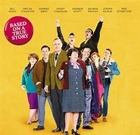 | 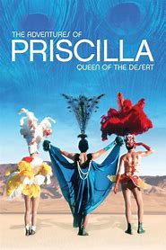 | 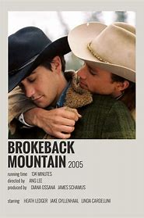
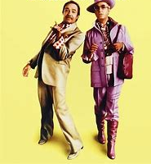 | 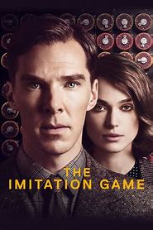 | 