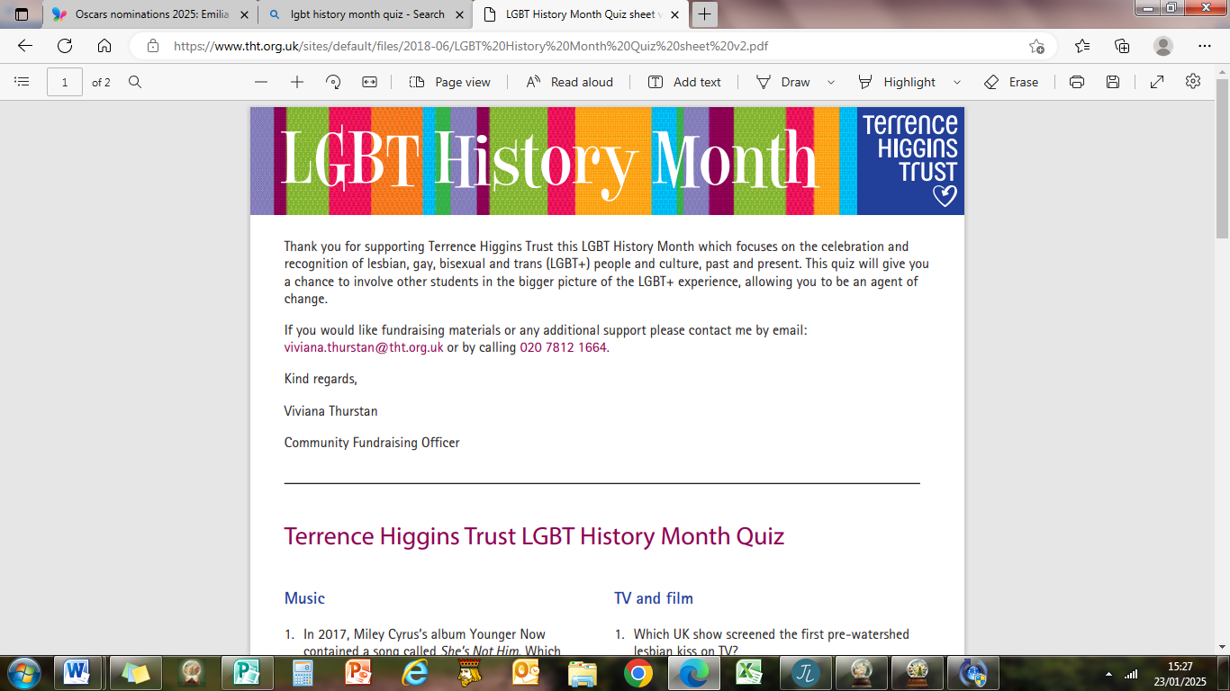
Terrence Higgins Trust LGBT History Month Quiz
Answers
Round 1 Music
1 Boy George
2 Kylie
3 Relax
4 EGOT (Emmy, Grammy, Oscar and Tony)
5 The Communards

Round 2 TV
1 Brookside
2 The Vivienne
3 Captain Jack Harkness
4 Mark Fowler in Eastenders
5 Queer as Folk

Round 3 Sports
1 Tom Daley
2 Brisbane
3 Martina Navratilova
4 Hockey
5 Kelly Holmes

Round 4 LGBT+ General Knowledge
1 Allan Horsfall
2 Greenwich Village 1969
3 1985
4 Ellen de Generes
5 Alan Turing
6 1991
7 Conchita Wurst
8 2001
9 James Anderton, God’s Copper
10 2013

Round 5 Films
- Pride 2014
- Priscilla Queen of the Desert 1994
- Brokeback Mountain 2005
- La Cage Aux Folles 1978
- The Imitation Game 2014
- My Beautiful Laundrette 1985

