

Annual Report 2023

Introduction

Out In The City is a social and support group for members of the Lesbian, Gay, Bisexual and Transgender communities who are over 50 years of age.

We are a self-organised group, supported by Age UK Manchester. We provide a safe meeting space in an accessible building in the centre of Manchester every week from 2.00pm to 4.00pm. We have tea or coffee, a chat and provide the opportunity to meet up with others.

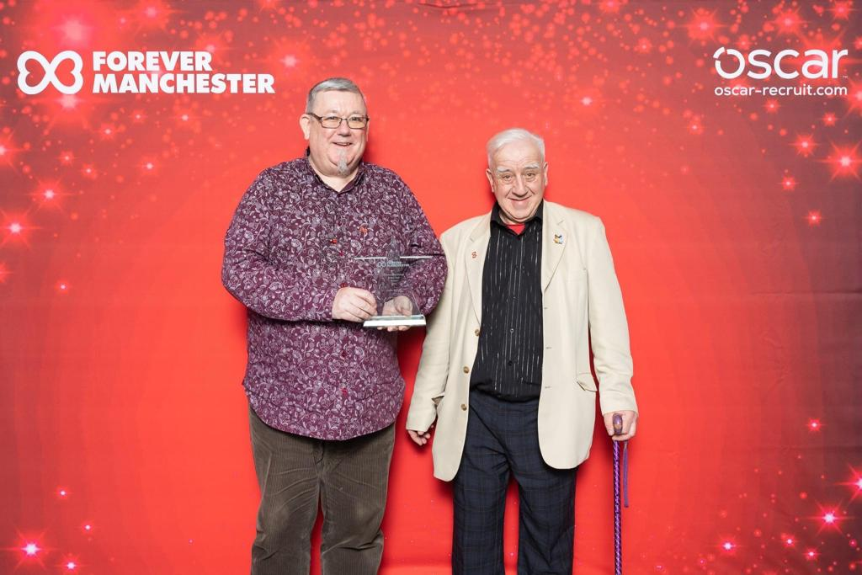

Out In The City won “Community Group of the Year” in an awards ceremony organised by Forever Manchester in February 2023.

One of our new members said: “Joining this group has been the best thing I’ve ever done”.

Another added: “I really appreciate the quality of the news you email to me. It makes me feel less isolated and better informed”.

Our Impact

During 2023 we held 51 face-to-face meetings with an average attendance of 21 people.

We also had 83 trips out with an average attendance of 16 people. These included three coach trips to Bakewell, National Mining Museum in Wakefield and Llangollen and 19 concerts at Bridgewater Hall. Highlights included the FOD x Smart Barnett Exhibition, Stockport Plaza Mystery Trip, Bee Corner, Legacy of ’67 Symposium, Bury Pride Rainbow Train, Scranchester Tour, 1853 Restaurant and “Beautiful Thing” at HOME.

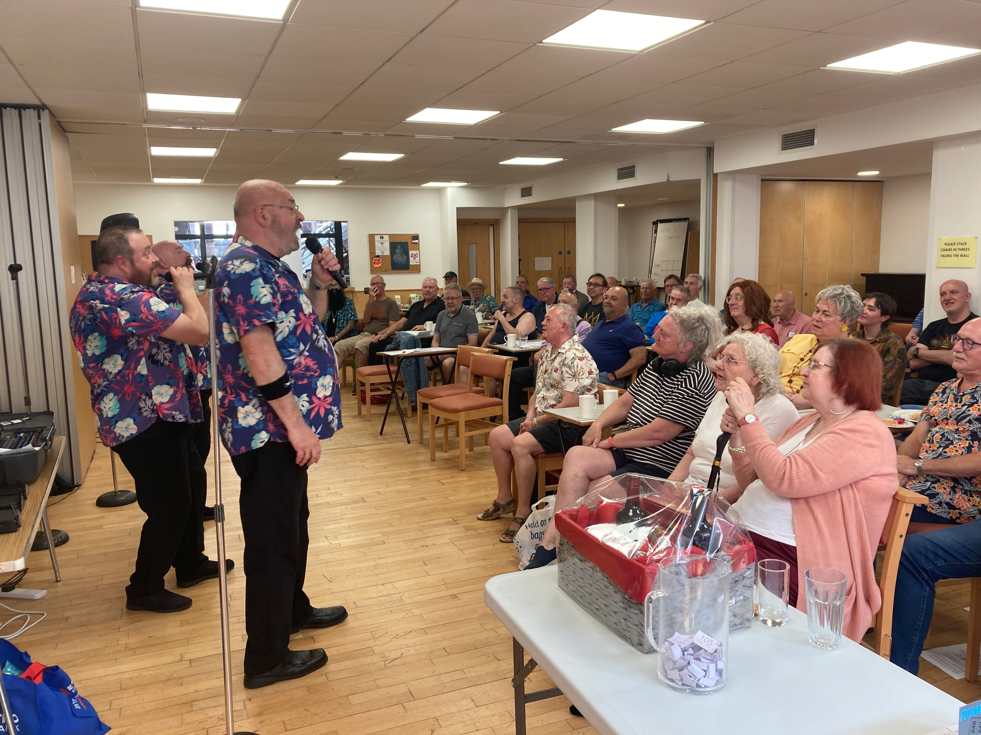

During our meetings in 2023 we had speakers from:
Co-op Bank on wills and financial planning;
Buzz Manchester Health & Wellbeing on falls prevention; Manchester Pride;
Gay Gordons (dancing demonstration);
Age UK Manchester on scams;
InHealth Intelligence on diabetic eye screening;
Vegetarian for Life (cooking on a budget demonstration);
University of Birmingham on Social Care Assessments for LGBT+ over 60s; and
Biffa on recycling.

Media

Members of the group were interviewed in The Telegraph, ALL fm radio, Manchester Central Library podcast, Daily Mirror, Age-Friendly Movement newsletter, BBC Radio Manchester, Centre for Ageing Better, The Guardian and Noel McDermott’s Wellbeing Show podcast.

The Talking About My Generation website featured three articles written by us: A trip to the National Coal Mining Museum; Pride on the Range; and Stockport Plaza Variety Show.

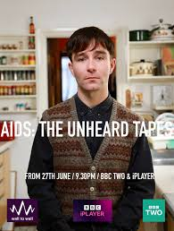

Tony was featured in all three parts of AIDS: The Unheard Tapes on BBC2 on 27 June, 4 July and 11 July 2022. The series was nominated for a BAFTA in the Specialist Factual category in May 2023.

We have a website and now have 316 followers (up from 240 last year) who receive

regular emails each week. The website has had 67,551 views (up from 53,467 views last year). There have been 10,929 individual visitors (up from 8,600 last year) from 98 different countries! A crowd of viewers has engaged with our content - a testament to its appeal and reach. We also have a private Facebook page with 124 members.

Of course our work is about far more than numbers. You can't easily put a number on laughter, independence, kindness or support.

We have undertaken interviews and projects with various students (Miriam, Matt, Charlotte, Andrew, Martin and George). Charlotte won an award for her photographic project under the category Social Change.

“I really have valued all the time spent with members of OITC, after my partner’s passing, I really wonder how I might have coped if I had not been able to find such warm and friendly companionship.”

“I have really enjoyed being out with the OITC gang, not just a safe place, but fun, I experience genuine care for everyone amongst the group, and there is good gentle humour amongst the group too, and to be made to feel welcome is just wonderful.”

Accounts for the year ended 2023:
Income:
Silver Pride £ 800.00
Telegraph Appeal £1000.00
Manchester Pride £1000.00
Auto Trader £1000.00
Forever M/cr £ 100.00
M/cr City Council £ 500.00
GM LGBTQ+
Community Fund £ 900.00
GM Mental
Wellbeing £4015.00
Rainbow Lottery £1304.50
Other Donations £ 703.00 Total £11322.50

Expenditure:
Food * £1458.50
Travel ** £2311.00
Activities *** £2771.33
Website £ 19.20
Room Hire £2253.00

Total £8813.03

Surplus: £2509.47

Money in bank £6273.80

* Includes Christmas meal for 46 people at 1853 Restaurant.

** Includes 3 coach trips and Bury Pride Rainbow Train.

*** Includes entrance fees to Stockport Air Raid Shelters, Bramhall Hall, Robinson’s Brewery Tour, Rochdale Pioneer’s Museum, Staircase House, Working Class Movement Library, Blackpool Model Village and many more.

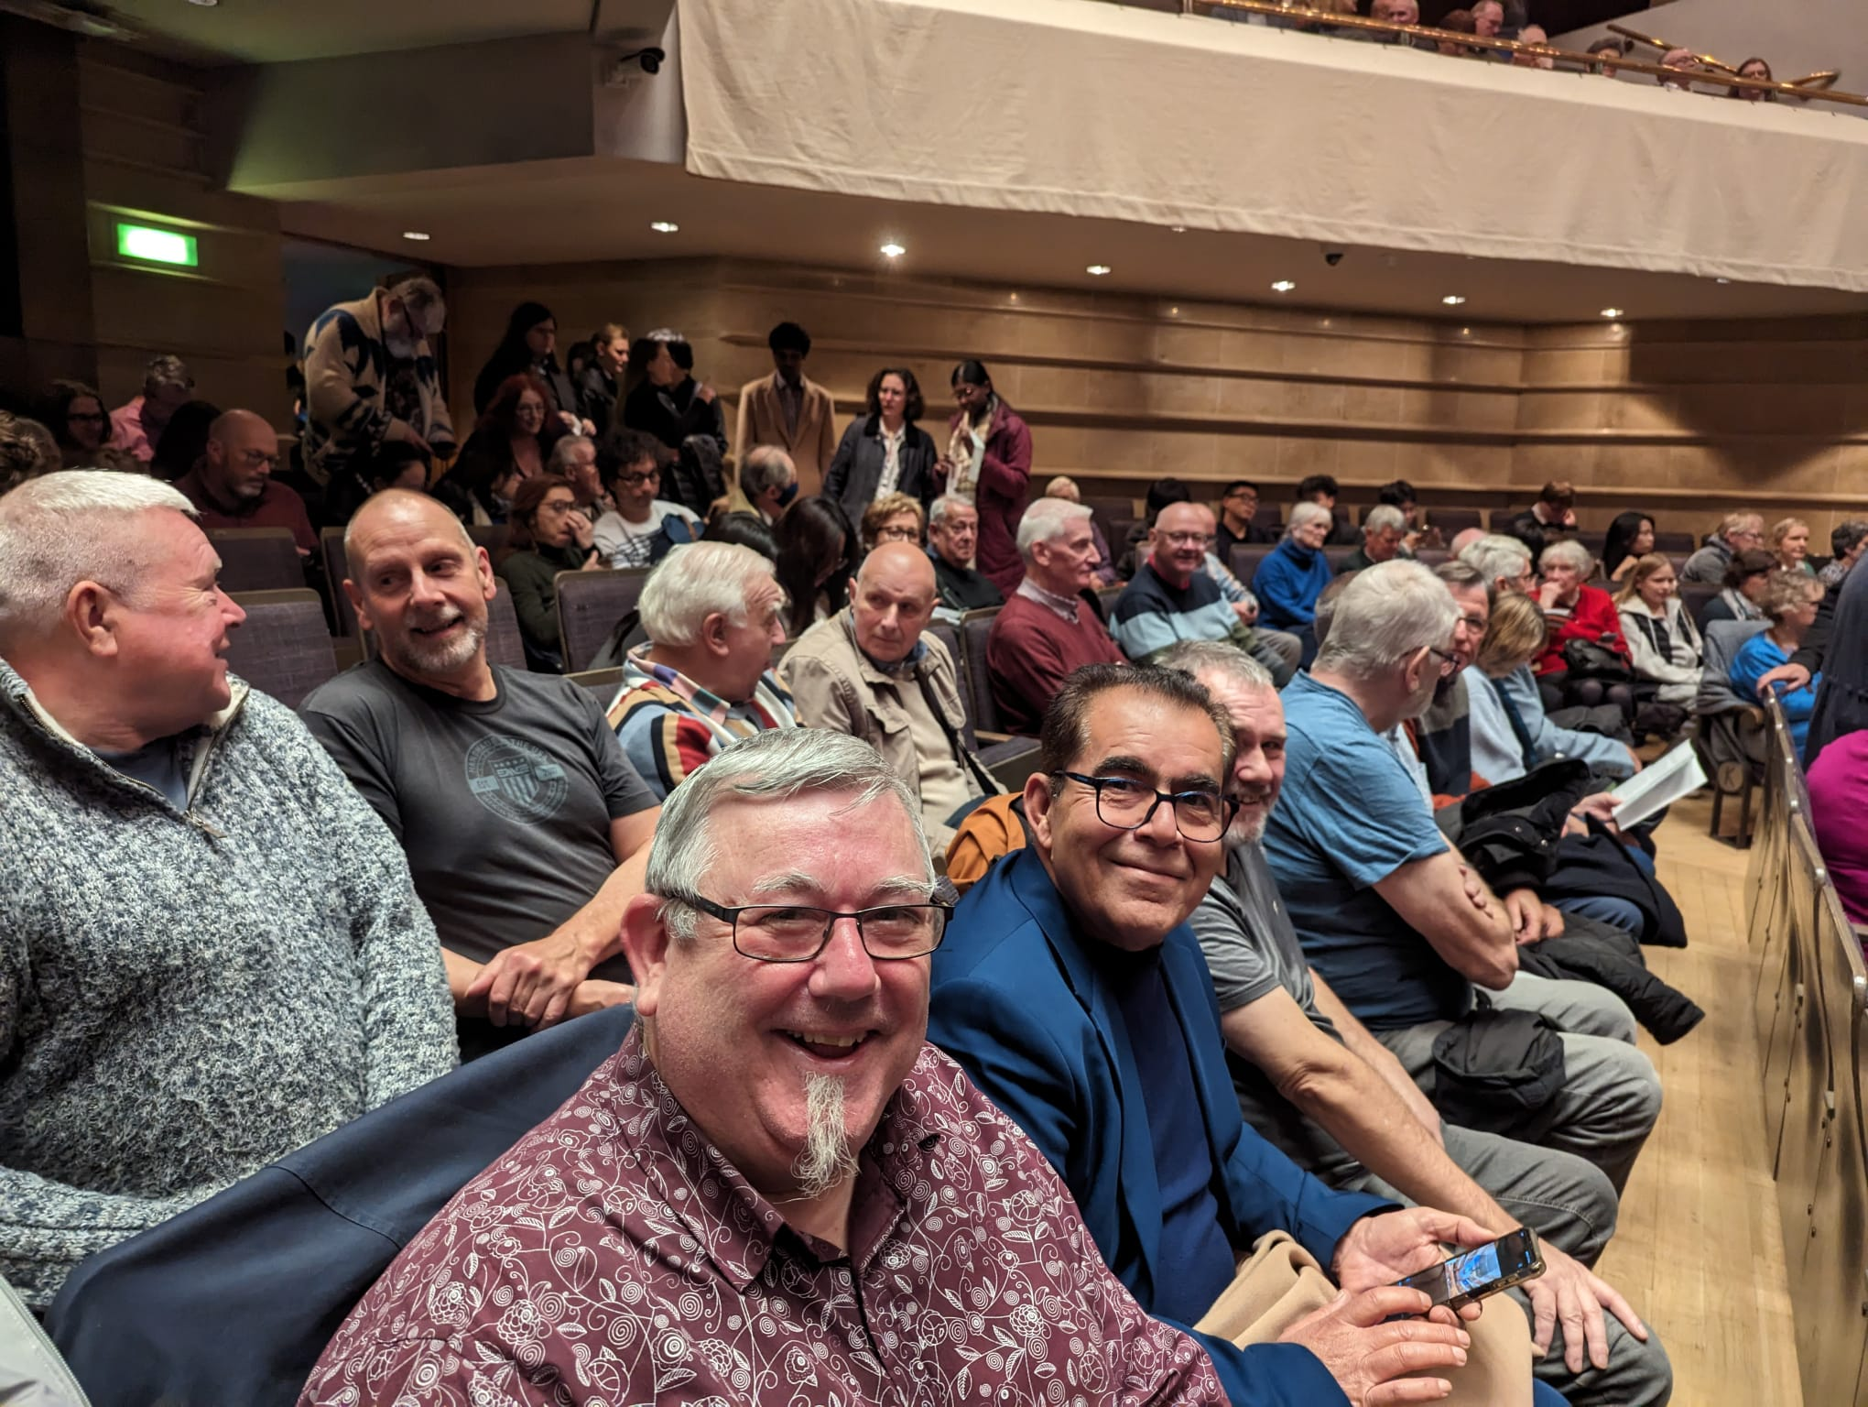
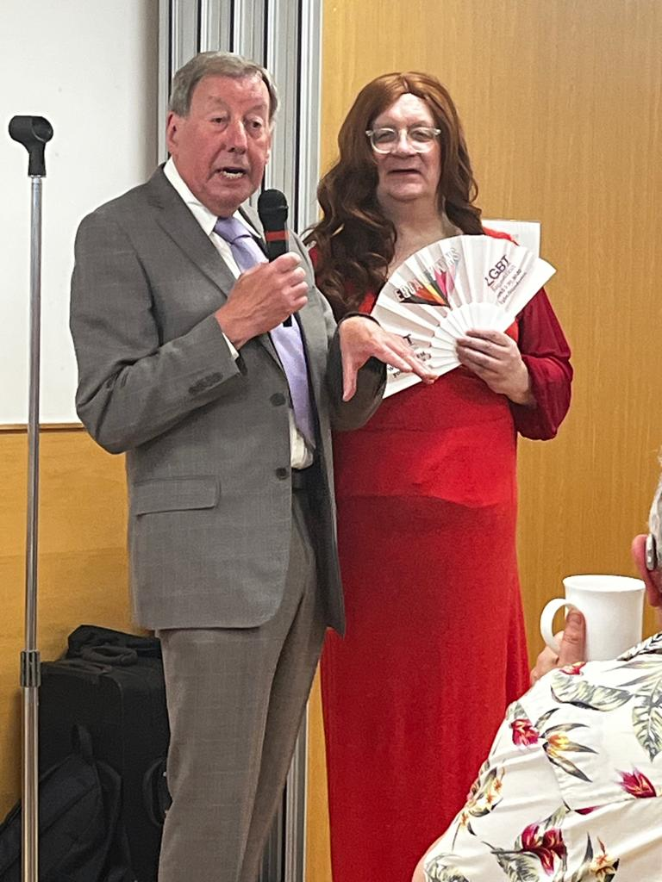
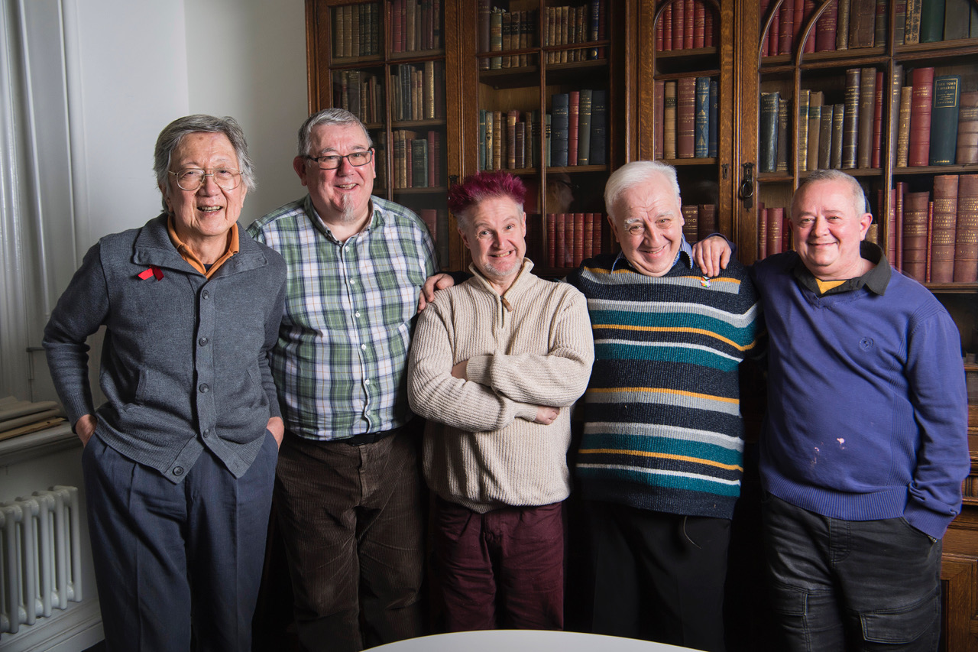
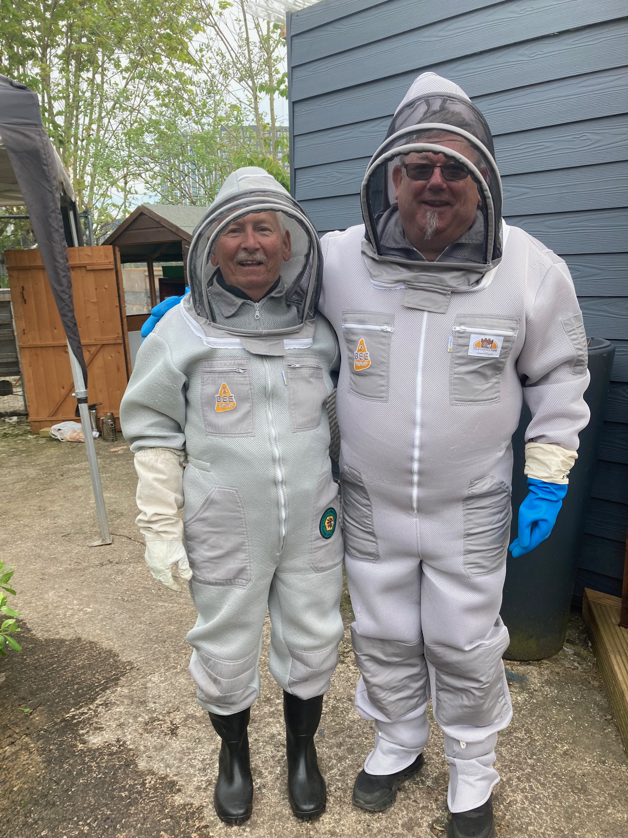
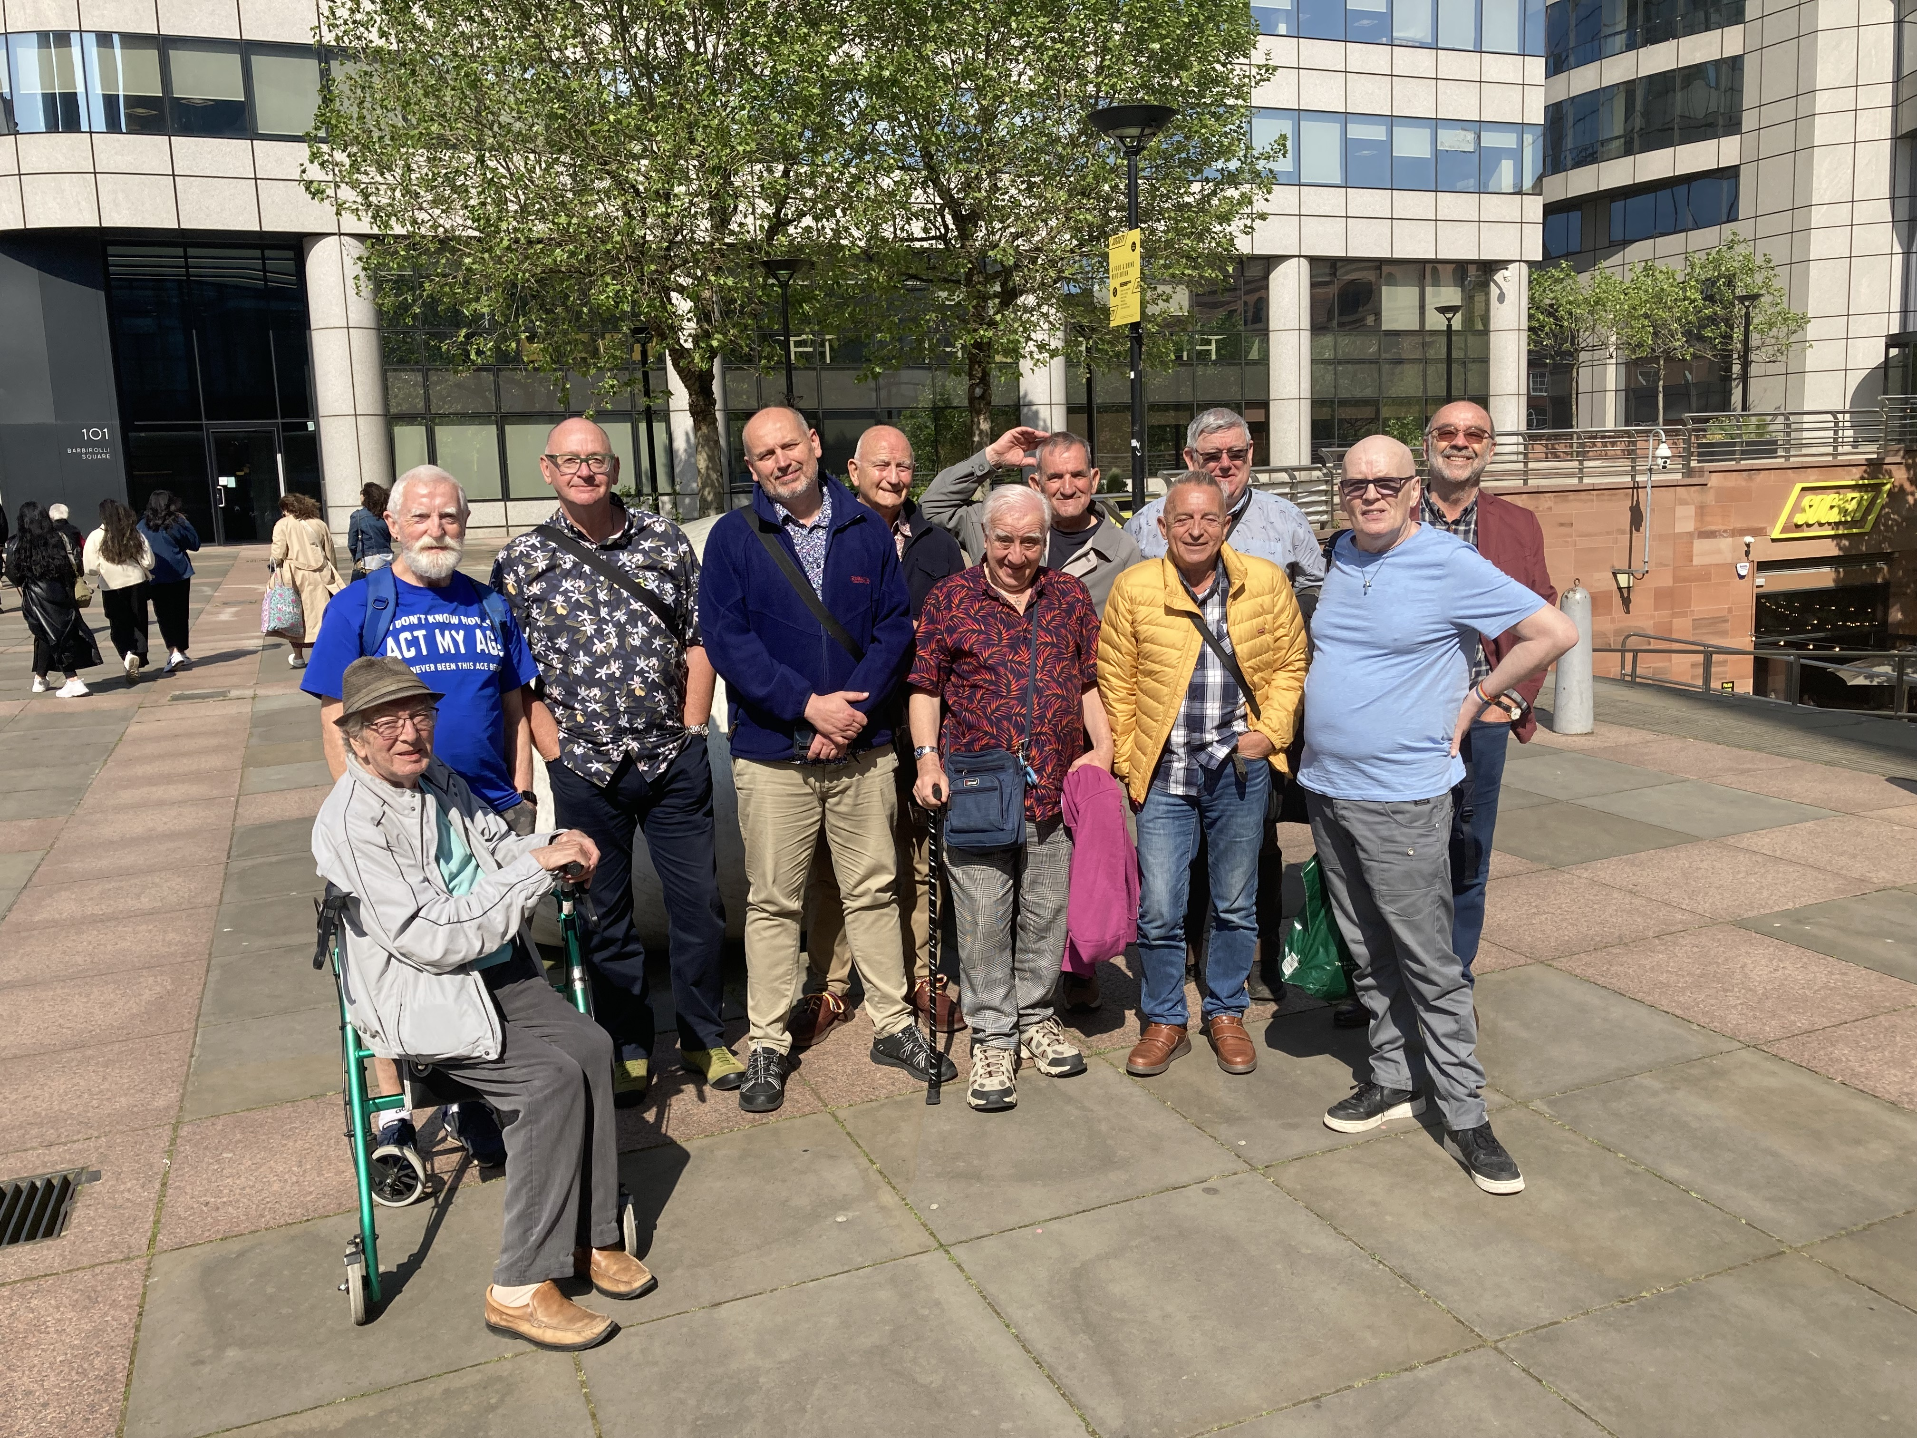
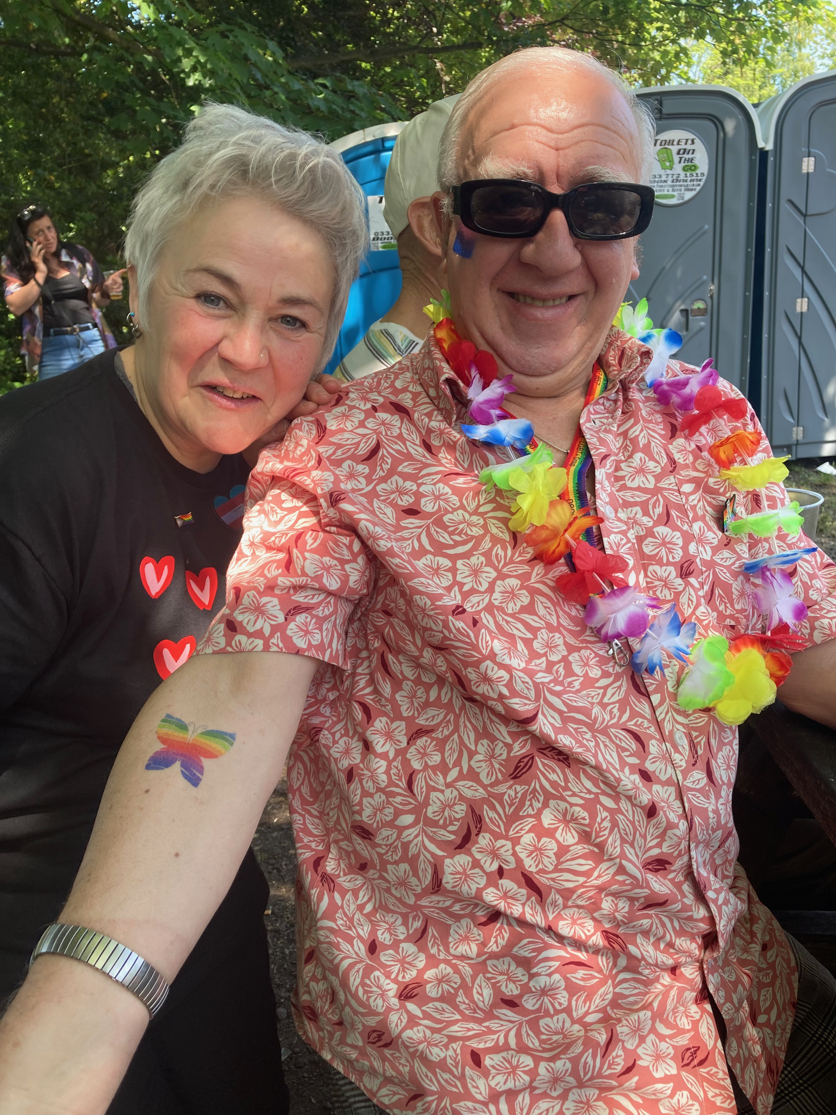
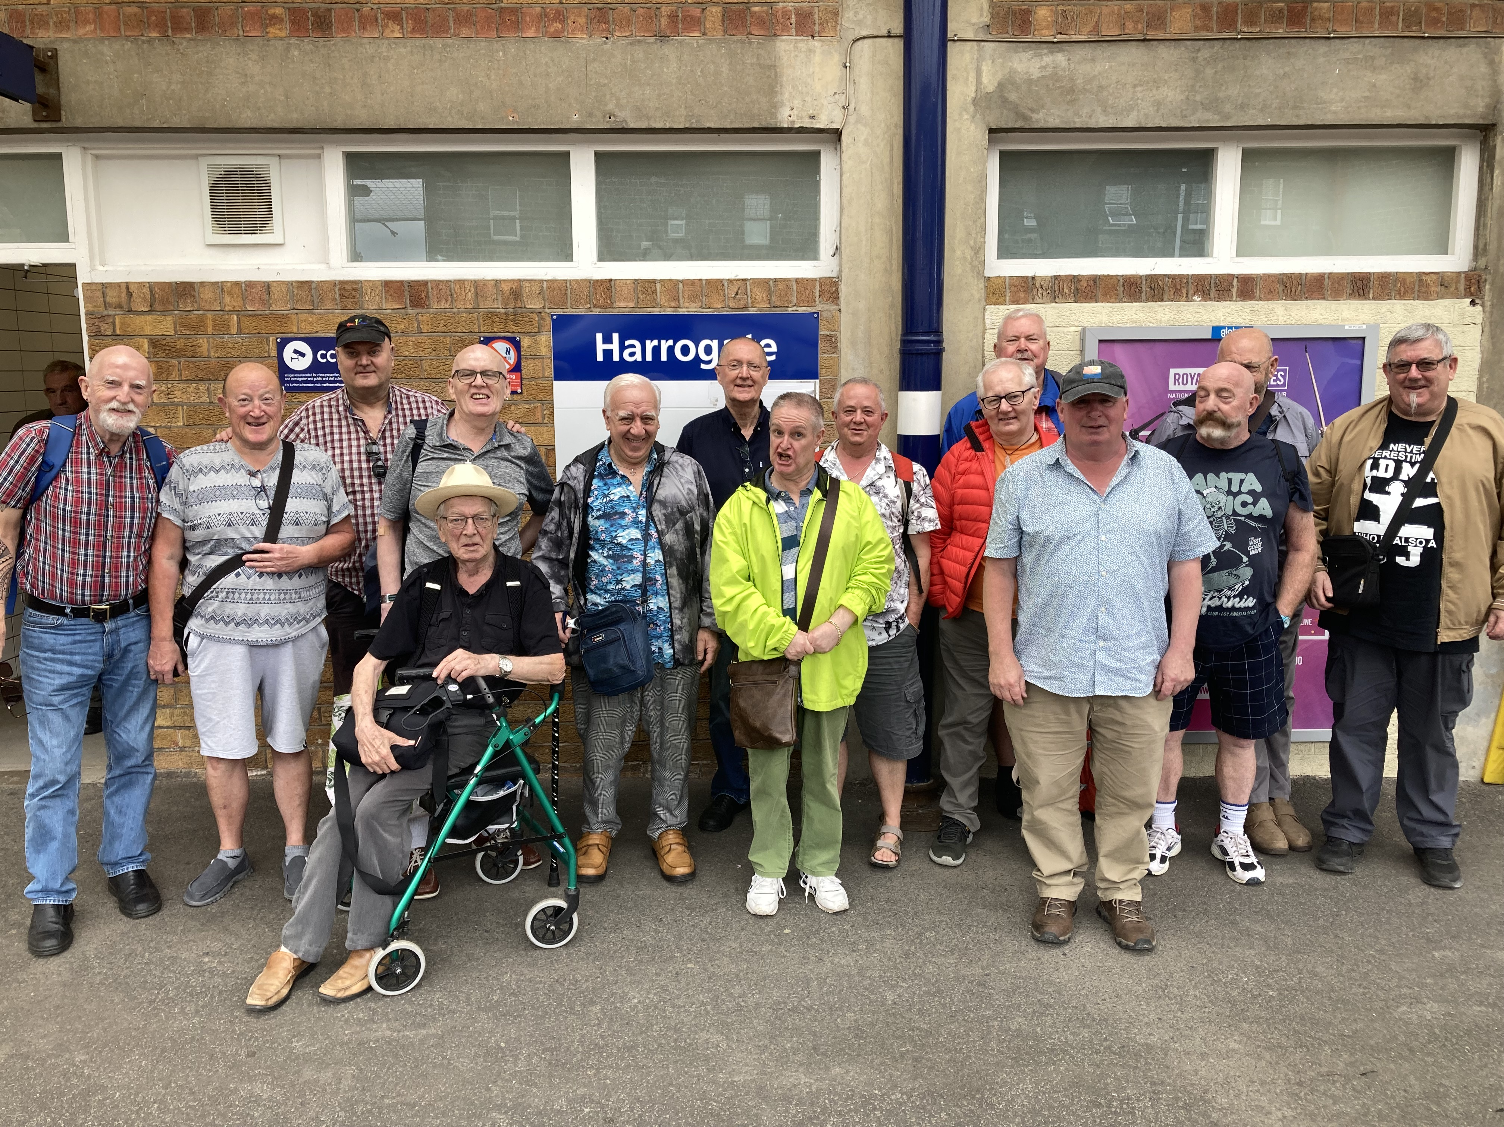

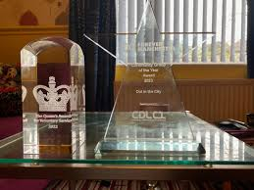
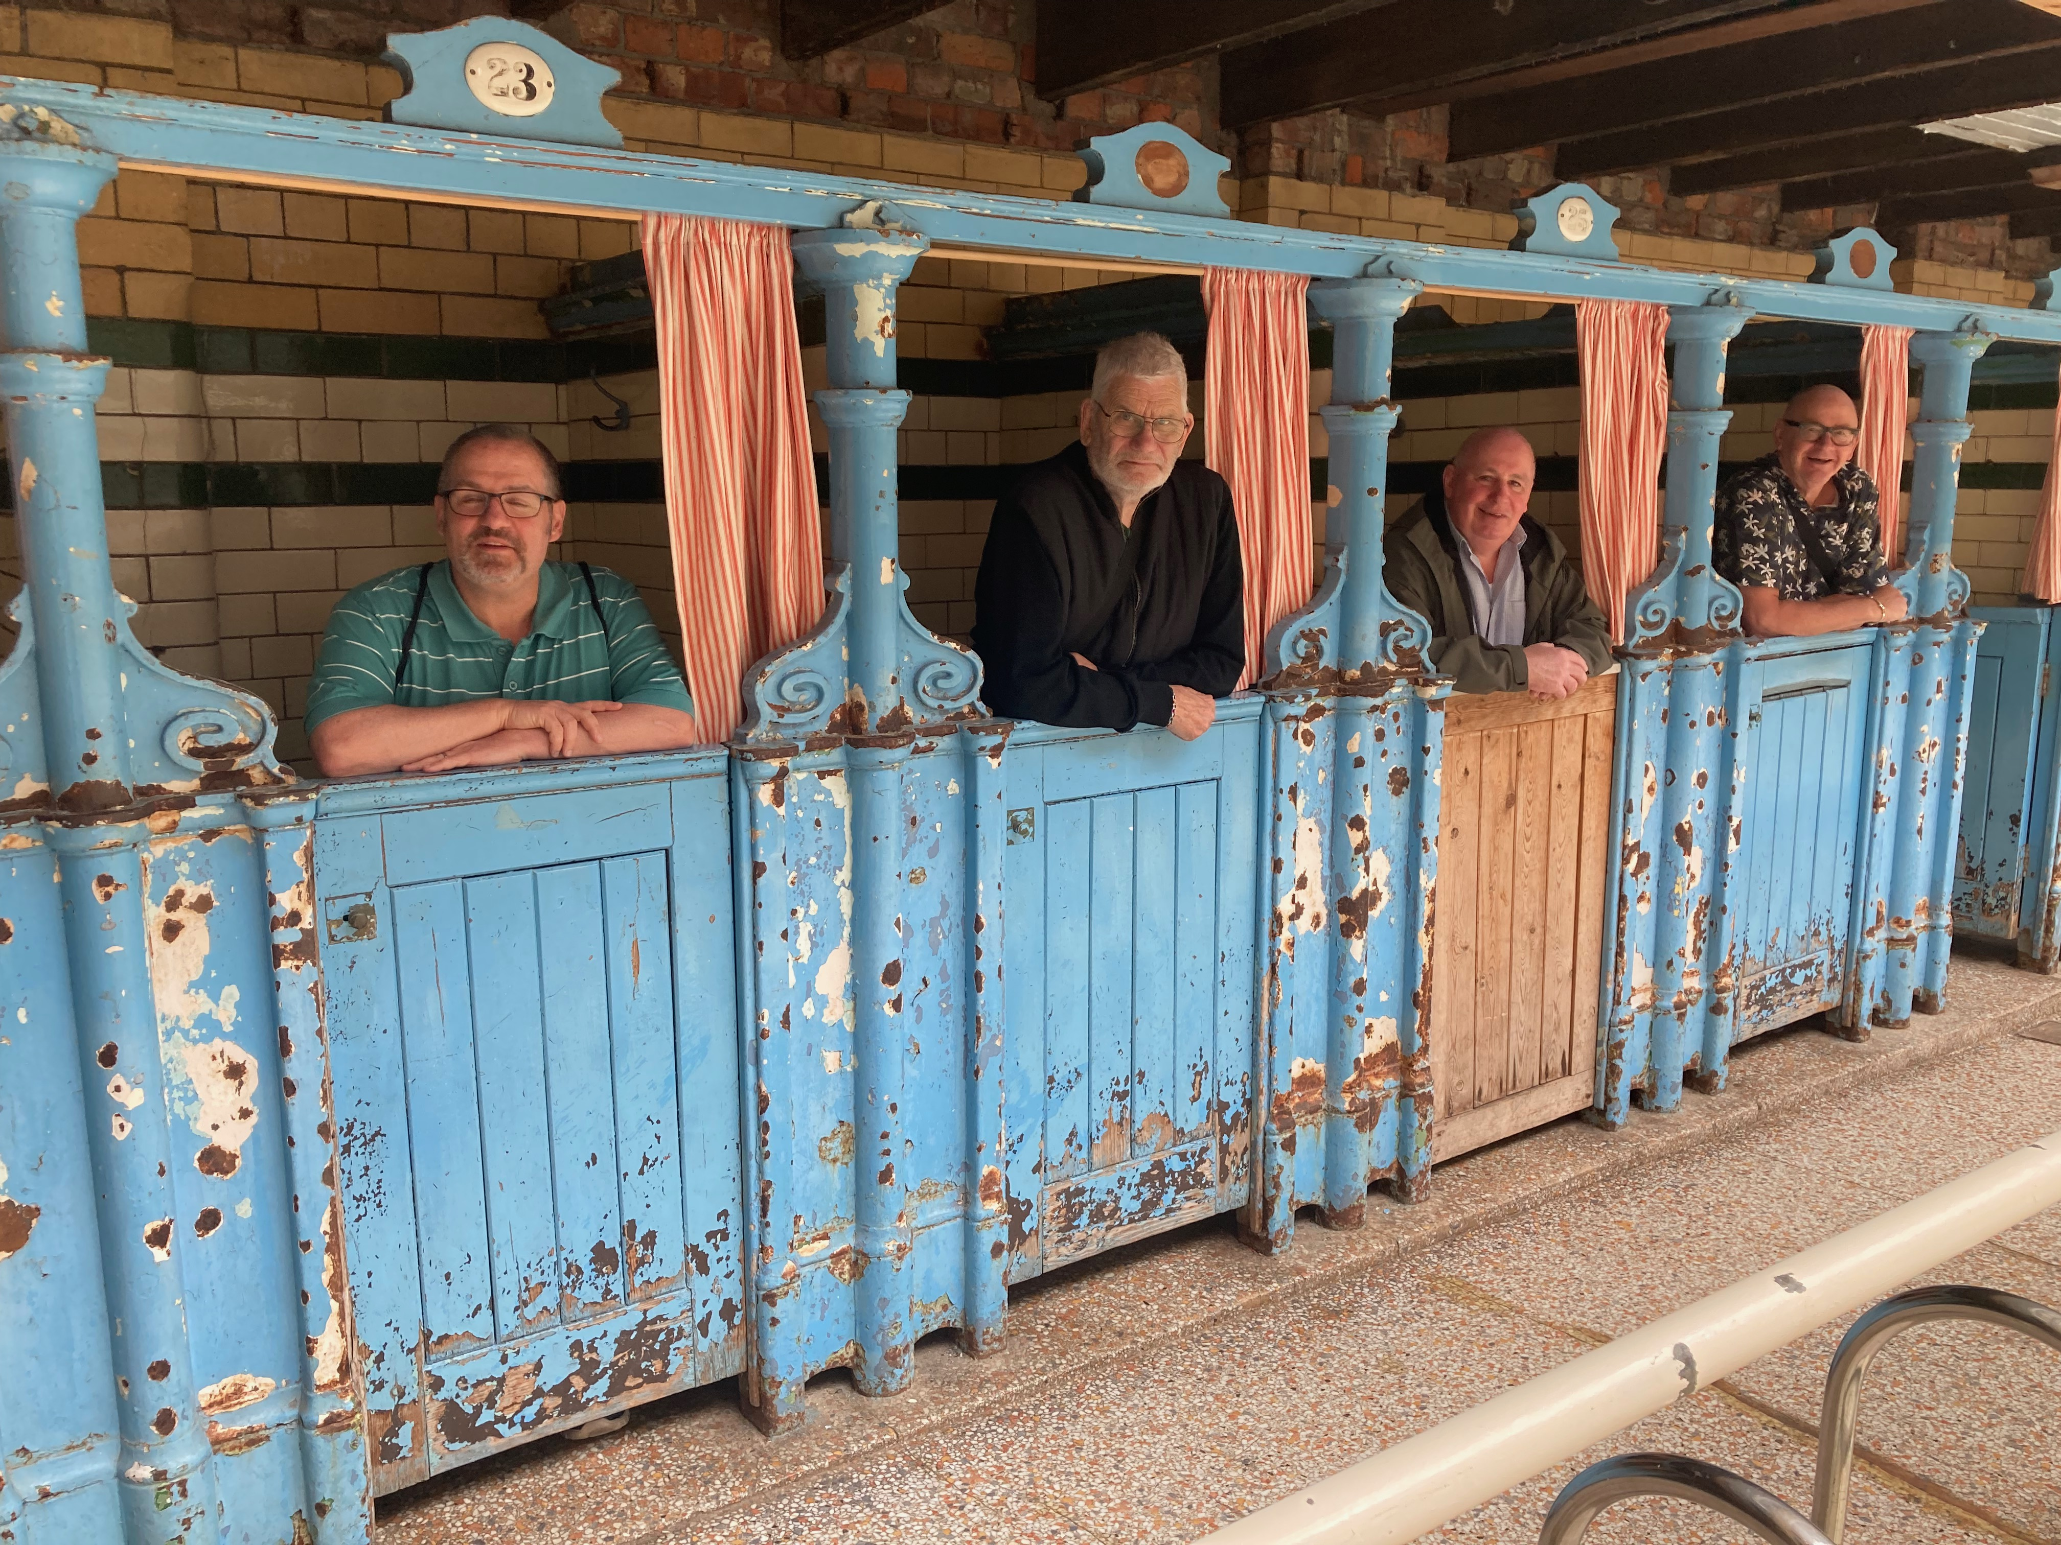
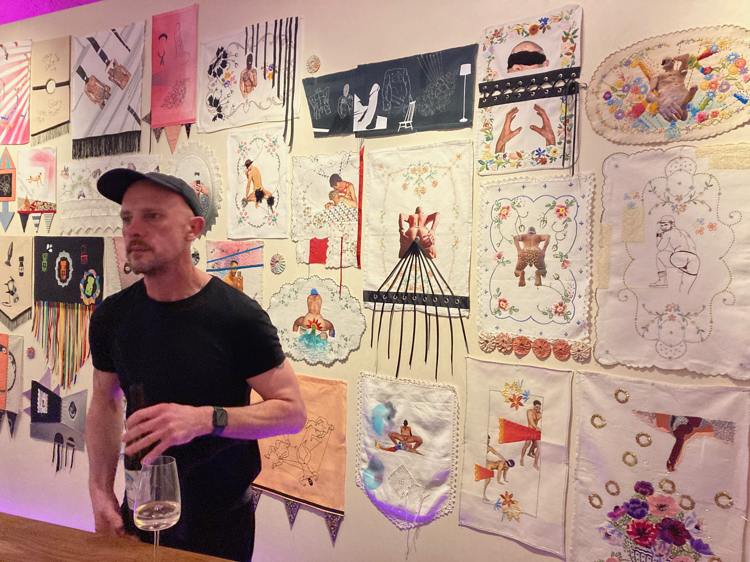

Thanks to our funders who have enabled our group to develop and have improved our social well-being:

LGBT+ Futures: Equity Fund (Silver Pride); Telegraph; Auto Trader; Manchester Pride; Forever Manchester; Manchester City Council; Greater Manchester LGBTQ+ Community Fund;
GM Mental Wellbeing; and Zuto Make A Difference Fund;

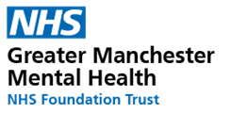
Supported by Greater Manchester Mental Health NHS Foundation Trust through the Manchester Wellbeing Fund
